SNOWFLAKE ARCHITECTURE
As to the continuation of previous post snowflake_5,
Snowflake has decoupled compute and storage in its architecture, so pricing is also decoupled
We had seen for compute charges earlier (snowflake_4) and for storage as shown (precisely) below
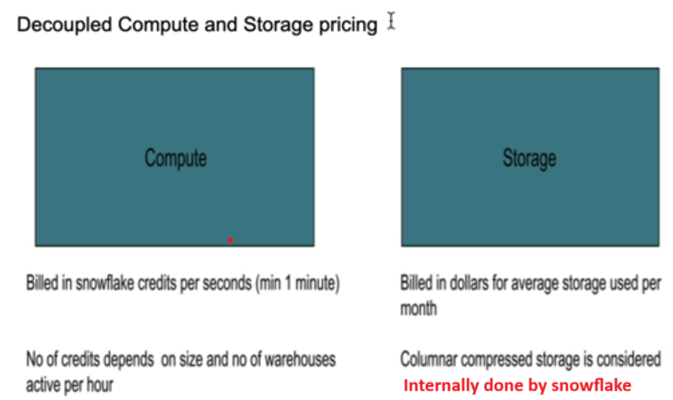

Credit to Dollar cost
Credits to Dollar for compute and Dollar for storage (not credit). It depends on:
1. Cloud provider (AWS or Azure or GCP)
2. Region
3. Edition
Let’s see with practically
Click on this link https://www.snowflake.com/en/data-cloud/pricing-options/

as you change your platform and region, the price varies accordingly
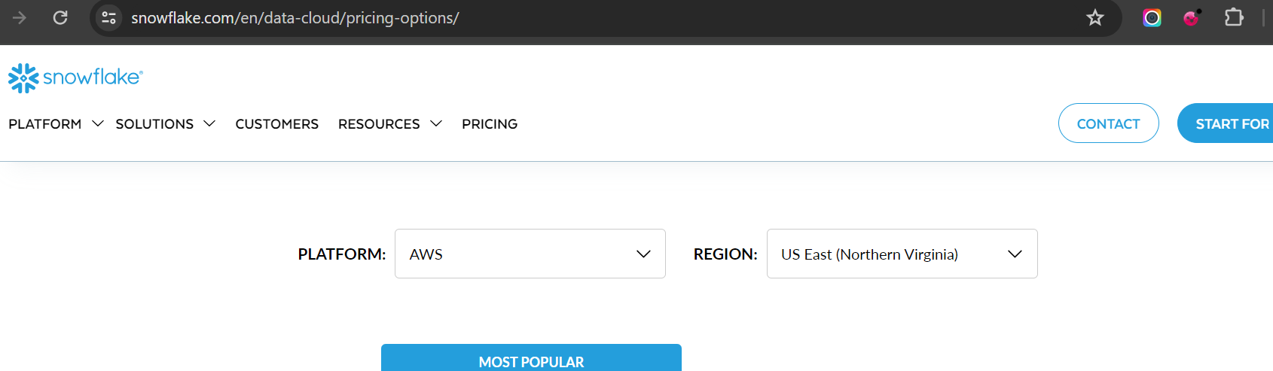
Compute cost:
As we had discussed snowflake editions
As per the requirement, you can select your own edition
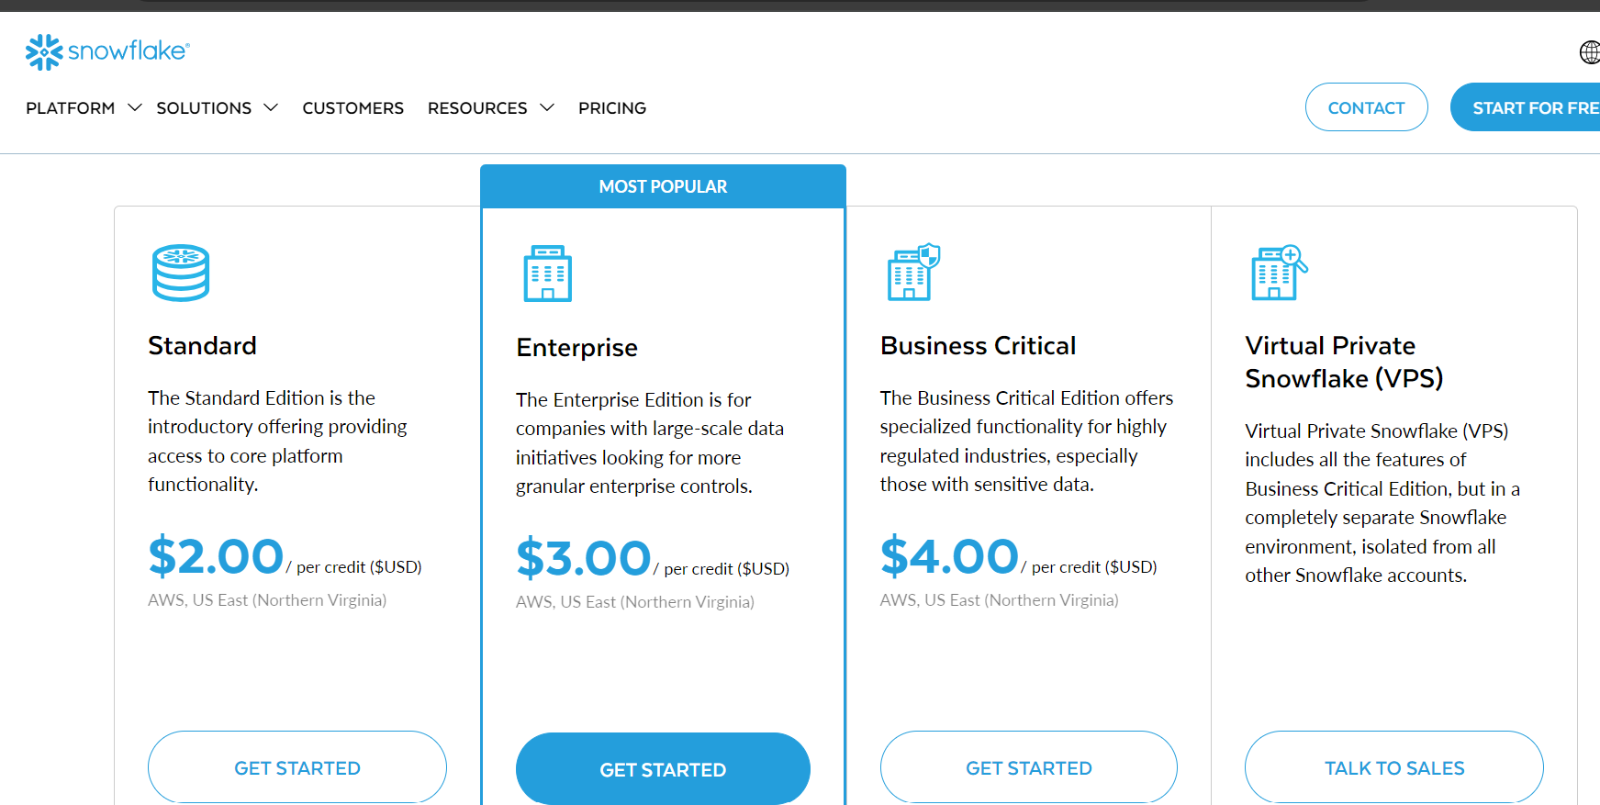
Storage cost:
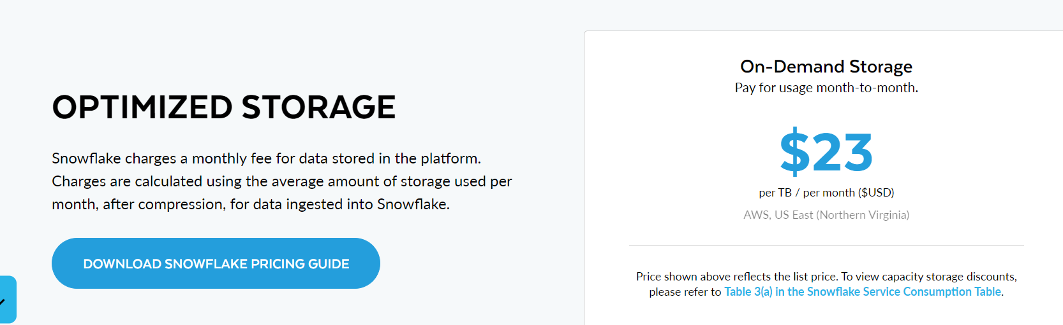

Credit consumption for storage
If you want to see the credits consumed and usage in snowflake, change your role to account admin and click on cost management
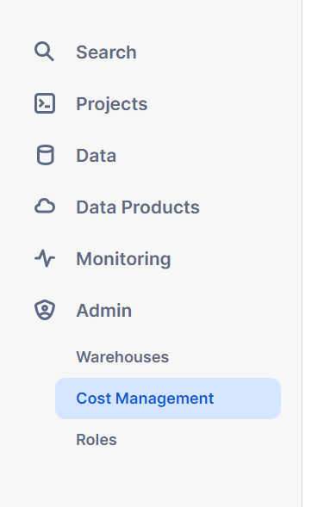
Now, you can go through different sections to see the usage and storage covering the cost
There are more terms to explain in this section which we will go further but just keep in mind for time purpose

Closing the snowflake Architecture topic

